***Results—***

Both ambient and low salinity had similar, positive effects on initial growth rates

The size at the start of the period had a positive influence on growth rate overall

TA did not have an effect on initial growth rates

There was an overall decline in relative growth rate in the later period. A severe decline in growth rate between initial and latent increments could indicate a switch between shell growth and tissue growth, however, due to not wanting to sacrifice individuals following the first increment, we lack tissue mass samples to corroborate.

There was a positive interaction between TA and time increment, indicating that the effect of TA became statistically significant in the later period. This may indicate that when oysters switch away from a calcification track to focus on increasing tissue reserves, the effect of TA condition to shell ‘maintainance’ becomes apparent

Similarly, we saw a positive interaction between the later period and lower salinity, indicating that lower salinity environments had higher growth in the later period than ambient salinity categories.

Need to look at these effects how we could expect them to change in nature: An effect of 0.0002 mm2/d per unit TA later on, could equate to 0.45 mm4/ d if TA levels were ~2250umol kg, or 0.20 if TA was 1000 umol kg. depending on how long organisms are switching back and forth, the effect of TA may have a greater role?

Initial size in actual values: Initial size had a 0.0012 mm2/d effect per surface area (mm2), indicating that the difference in growth between our smallest individuals (60 mm2) and largest, (160 mm2), would was 0.07 mm2d-1 and 0.192. This indicates that larger organisms were taking advantage of conditions overall, or that smaller individuals may have suffered a higher energetic cost to changing conditions.

salinity or TA had a significant effect on net shell growth, indicating that oysters in well-fed conditions can overcome corrosive seawater conditions to maintain shell growth.

The effect of starting size persisted, not surprising

We did not see any impact of seawater TA and S conditions, on the CI, but did see a positive effect of size, indicating that CI generally increases as organisms get bigger (not surprising). The effect of initial size of CI was small than its effect on shell growth.

We did not see any impact of seawater TA and S conditions, nor the size of the individual, on the thickness of the shell. ie oysters did not sacrifice shell integrity in instances of elevated shell growth

The fact that we did not see an effect of TA or S on CI, combined with no difference in shell mass/area, means that larger shells, that weighed more, were matched per unit in tissue growth (to see no net change in the relationship) by the end of the experiment.

-Whether they went through different pathways to get there is a good next focus.

Average tissue mass greatly exceeded that of un-fed oysters held in lab seawater (X vs X) indicating an ability of all oysters to assimilate and store food as tissue mass.

***Incremental growth: ADD IN PATTERNS WITH SA***

*Regardless,*

* Shell growth rate declined in the second half of the experiment overll; rather than investigate the difference in growth, we are interested in whether patterns of growth, regardless of amount, differ through time.
* We saw different patterns between TA and shell growth in the two growth phases; with the effect of TA not showing up until later, and even so, being minimal
* Average growth rate did not differ among oysters exposed to reduced, ambient, or elevated alkalinity (stats), in either salinity, within the first two weeks of exposure
  + In the following two weeks, although a trend begins to appear, average growth rate still did not differ among TA treatments in ambient salinity
  + In contrast, after two weeks exposure to low S and altered TA, oyster growth over 2.5 weeks was higher in the high TA conditions than the DI treatment but did not differ from low TA. Oysters in low TA and DI also did not statistically differ.
  + Net growth rate was the same pattern as incremental growth for ambient salinity, and the same pattern as the second incremental growth increment in low salinity.
* Although the reduced TA treatment exhibited an average omega calcite < 1, mussels maintained calcification rates. In contrast, those exposed to elevated TA did not appear to elevate calcification, indicating that all of the mussels in ambient salinity conditions performed similarly.
* We did not see a significant difference in growth between oysters with DI vs low TA, even though omega spanned below 1 to above 1.

***Ambient salinity— trend but not significantly different***

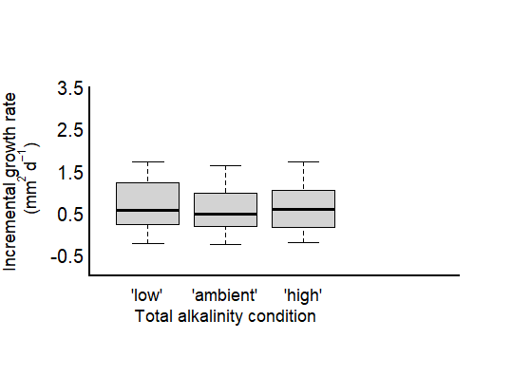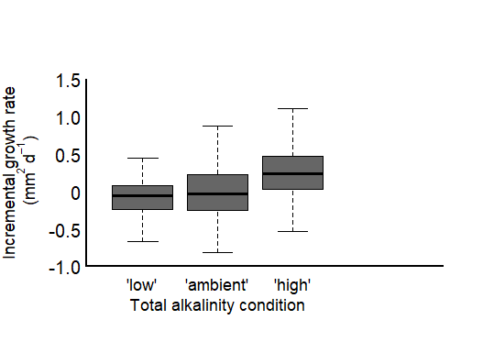

*days 0 - 18*

*days 18 - 36*

***Low salinity—***

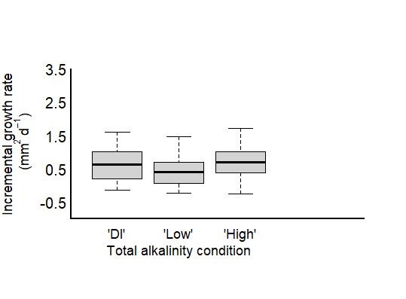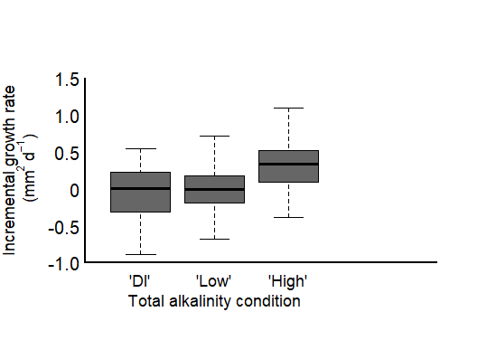

a

ab

b

*days 0 - 18*

*days 18 - 36*

***Net growth:***

***Shell mass per area & Condition index AMBIENT & LOW salinity—***

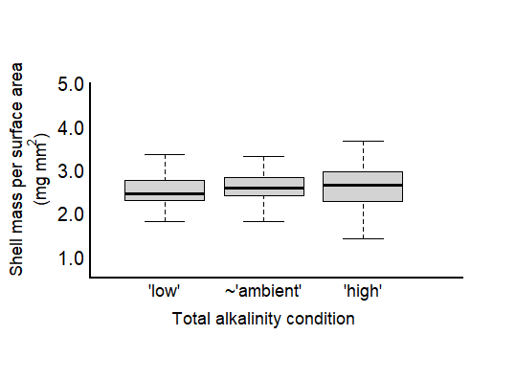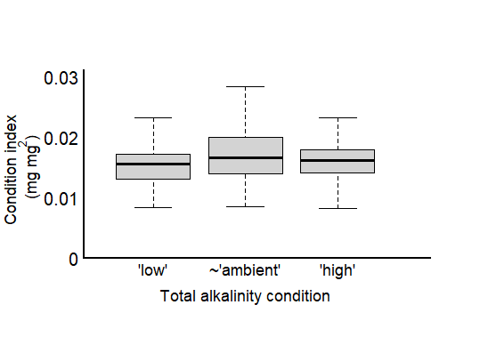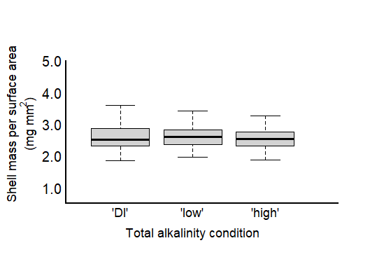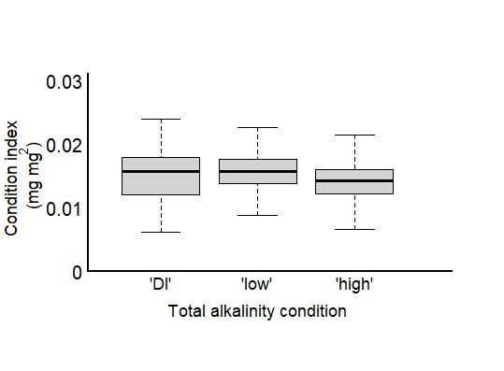

*(S = 34)*

*(S = 34)*

*(S = 27)*

*(S = 27)*

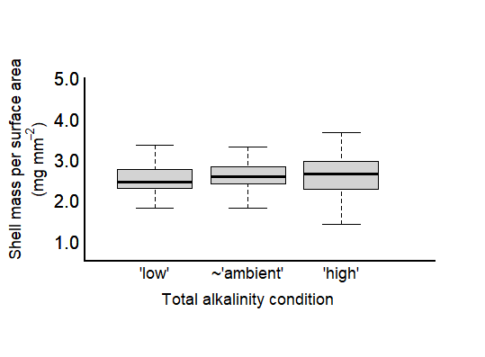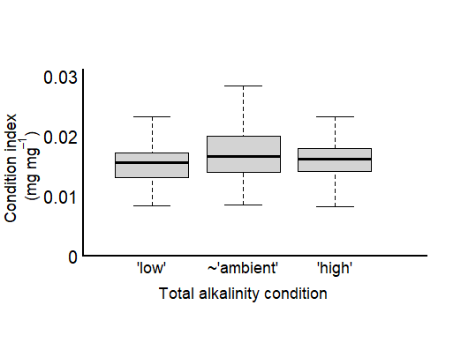

**ex are driven by changes in shell growth and not by differences in soft tissue mass—**

* Grew more with more food relative to oysters in flow through system (add ave line from control oysters to plot?).
* No effect of TA or S (or pH/Omega) on soft tissue mass overall;
* Increased CI is due to change in shell growth and not tissue wt.
* Shell mass per area also did not change between the treatments (add ave line from control oysters to plot?).

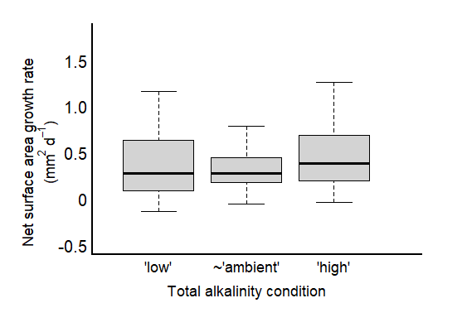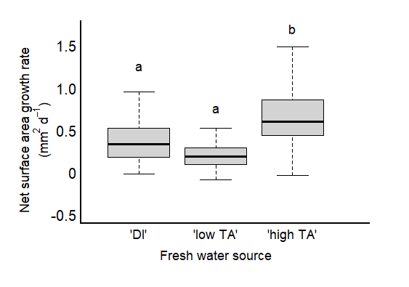

Fig. 4

**OLD MATERIAL BELOW:**

***Was the effect of SA.start***

**Incremental shell growth—**Oyster net growth was predominantly driven by growth occurring in the first experimental increment (0-18 days), as overall growth rates were significantly reduced in the second increment (18-36 days) (Figure x). Regardless, growth patterns changed, in the second incremental period suggesting that the effect of elevated TA, although weak, may strengthen the longer an oyster is exposed to high TA conditions (independent of salinity treatment). The effects of TA on incremental growth detected in the second experimental increment, though, contributes far less to overall growth patterns than the negligible effect of TA in the first increment.

We saw benefits of high TA on growth in low salinity conditions after the first experimental increment, whereas, the effect of TA was not detected in ambient salinity until the second increment. This may suggest that oysters were able to switch over their physio machinery to optimize growth in their preferred condition (lower S and high TA) more quickly than those in ambient salinity.

***Focus on: the fact that shell growth was not impaired by low TA conditions in ambient salinity and that controlling for TA led to different net growth responses in low salinity conditions.***

**Net shell growth—**Responses to TA condition differed between the two salinity treatments. Combined with ambient salinity, TA condition did not have a significant effect on average net surface area shell growth (Table X, Fig. X). Low TA conditions corresponded to the saturation state of calcium carbonate frequently < 1 (S. Table X), indicating oysters in these conditions were experiencing seawater-driven dissolution. In contrast, ambient and elevated TA conditions fell well above the O precipitation threshold and therefore oysters in these conditions were void of saturation stress. With this in mind, a similar net shell growth rate across our treatments could occur if oysters in low TA conditions were able to biologically increase gross calcification to compensate for low-omega derived shell loss. Oysters in ambient and elevated TA conditions did not elevate net shell growth rates, however, WHY?.

In lower salinity, net surface area shell growth was highest in the highest TA condition (Fig. X). In low salinity conditions oyster net growth rates were X in two different TA conditions (X and X) that fell below and above CaCO3 saturation. Growth in both low S and TA conditions was significantly lower than in the ambient salinity, indicating that although shell loss from abiotic dissolution was compensated, oysters performed worse overall when low TA accompanied lower S, regardless of saturation state.

Although we did not directly quantify seawater-driven shell loss, visible loss of organic periostracum material and underlying, external shell was apparent by day 18 of the experiment as a function of the CaCO3 calcite mineral form saturation state (Figure X). We did not detect a significant difference in the measured shell thickness, however, indicating that oysters were able to maintain similar shell mass per area (stats).

**Tissue growth and condition index—**Oysters maintained similar tissue mass, that was greater than average non-experiment oysters, in all salinity and TA conditions (stats). Further, oyster tissue mass to shell ratios were higher in all treatments than in non-experiment oysters, treatment conditions supplemented an improved biological condition. Oyster condition trended lower in X condition, though, the means didn’t differ statistically (stats). As tissue mass didn’t vary, this suggests differences in biological condition among oysters, were likely driven by differences in shell growth and not tissue mass.

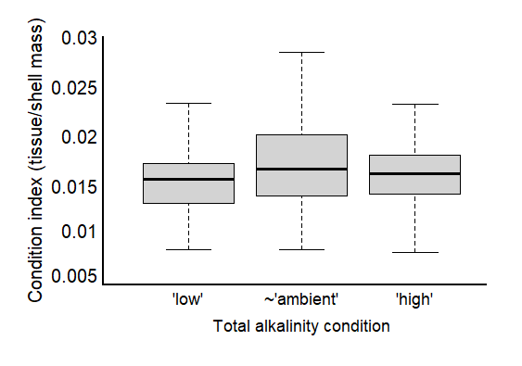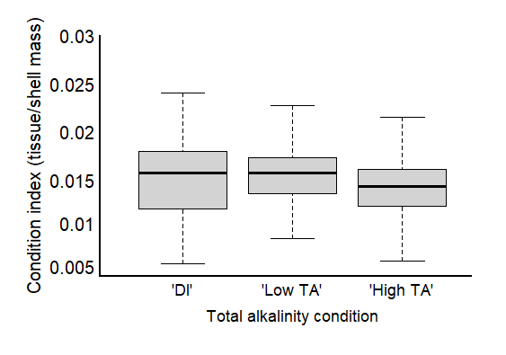

Fig. 6